FRACTIONS
Pearson Edexcel - Tuesday 19 May 2020 - Paper 1 (Non-Calculator) Foundation Tier

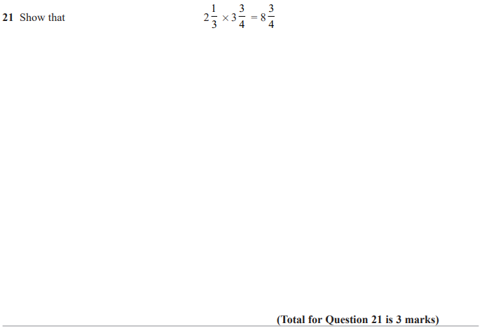

Pearson Edexcel - Tuesday 21 May 2019 - Paper 1 (Non-Calculator) Foundation Tier

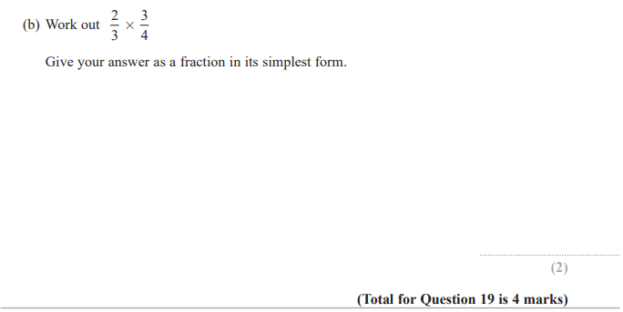

Pearson Edexcel - Tuesday 6 November 2018 - Paper 1 (Non-Calculator) Foundation Tier

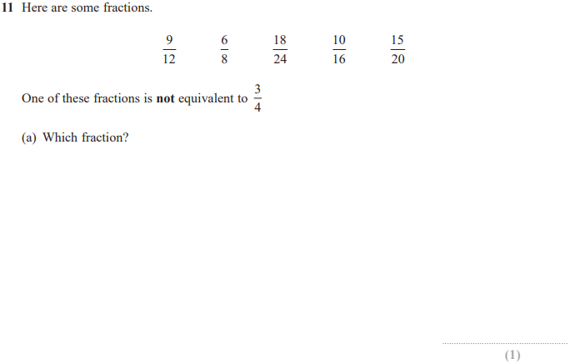
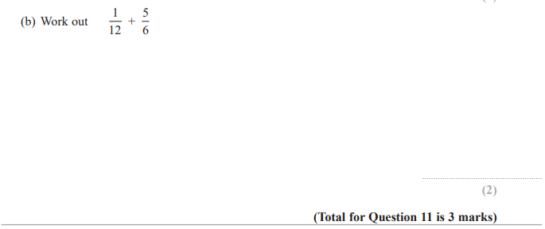

Pearson Edexcel - Thursday 24 May 2018 - Paper 1 (Non-Calculator) Foundation Tier

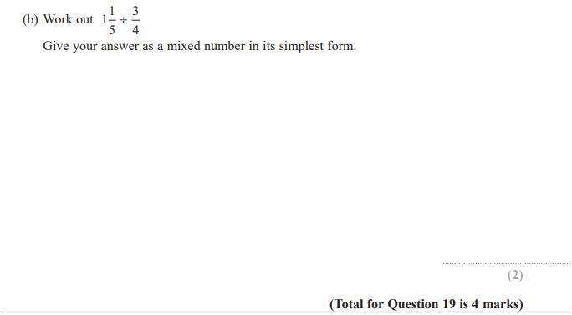

Pearson Edexcel - Thursday 2 November 2017 - Paper 1 (Non-Calculator) Foundation Tier

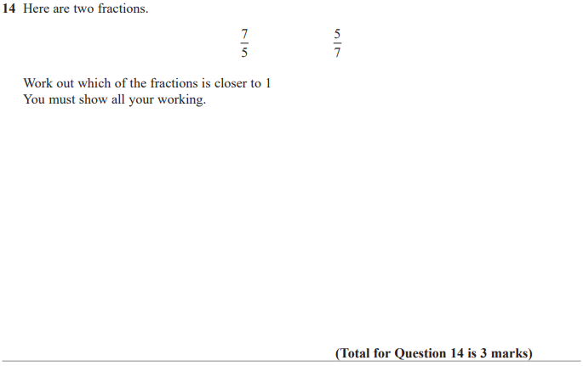

Pearson Edexcel - Thursday 2 November 2017 - Paper 1 (Non-Calculator) Foundation Tier

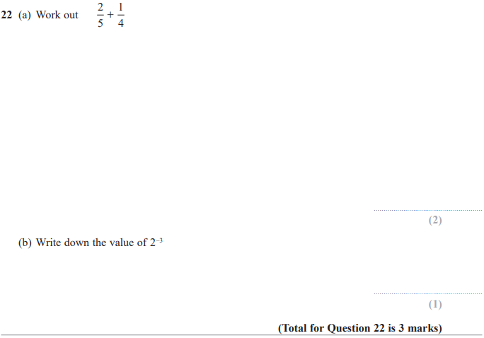

Pearson Edexcel – Specimen 1 - Paper 2 (Calculator) Foundation Tier

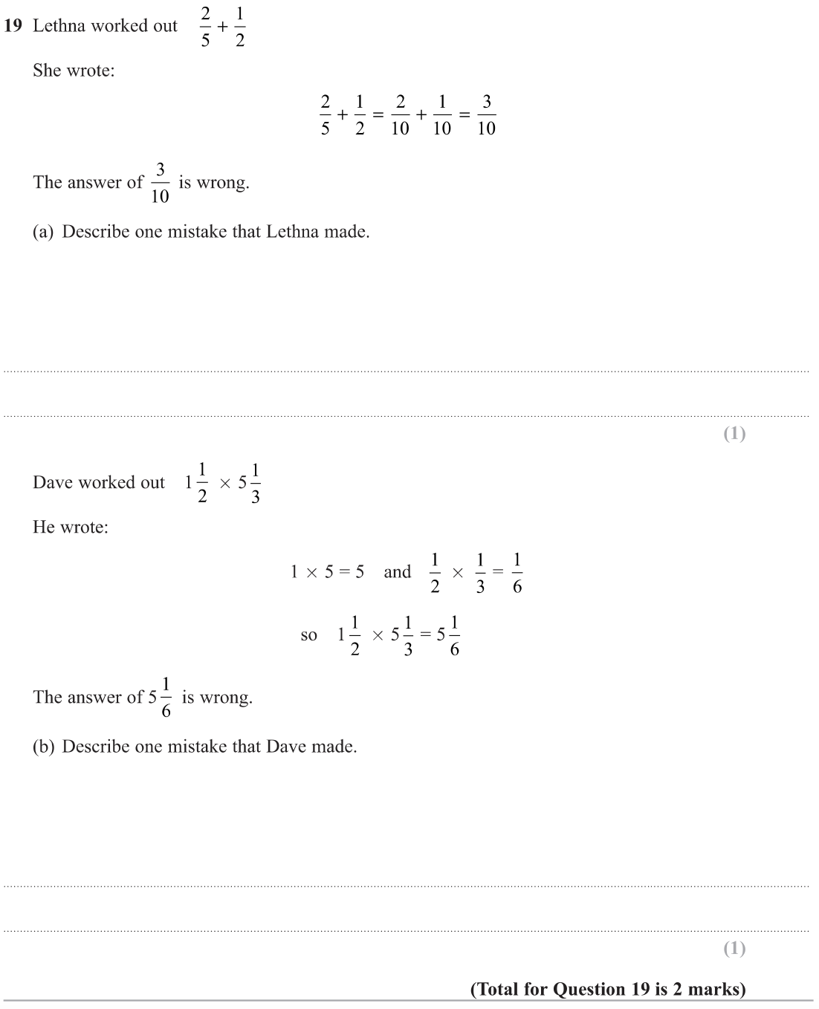

Pearson Edexcel – Specimen 1 - Paper 3 (Calculator) Foundation Tier

Pearson Edexcel – Sample Paper 1 (Non-Calculator) Foundation Tier
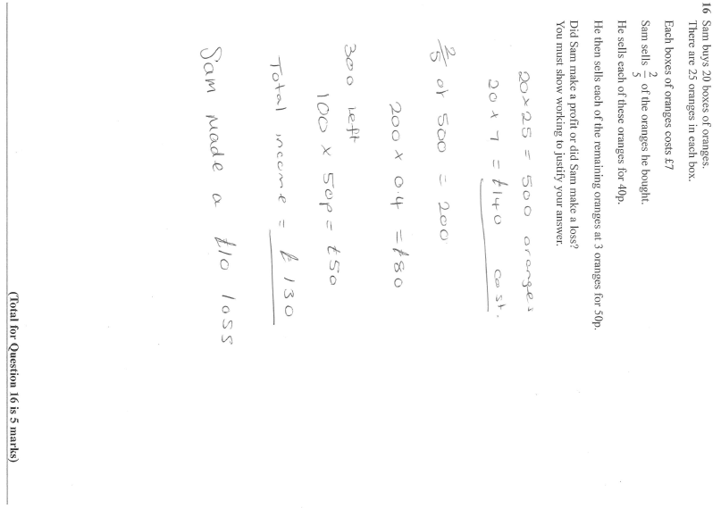
Pearson Edexcel – Sample Paper 1 (Non-Calculator) Foundation Tier
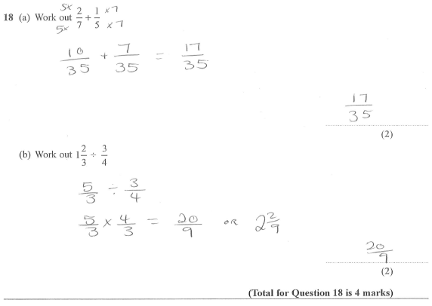

OCR Thursday 6 June 2019 – Morning (Non-Calculator) Foundation Tier
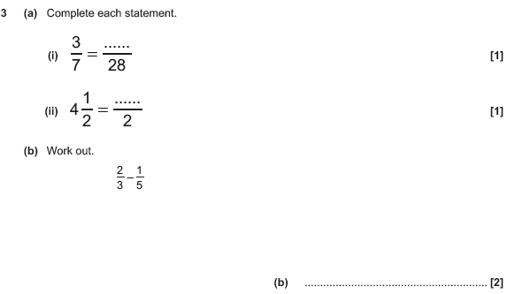

OCR Monday 12 November 2018 – Morning (Calculator) Foundation Tier
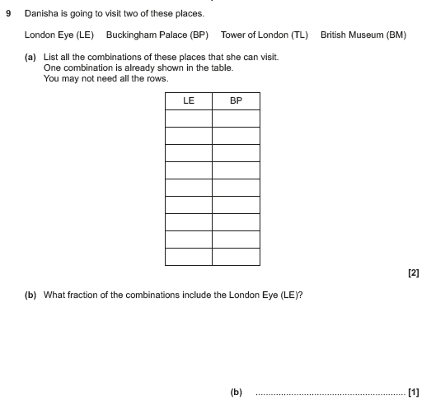

OCR Thursday 7 June 2018 – Morning (Non Calculator) Foundation Tier
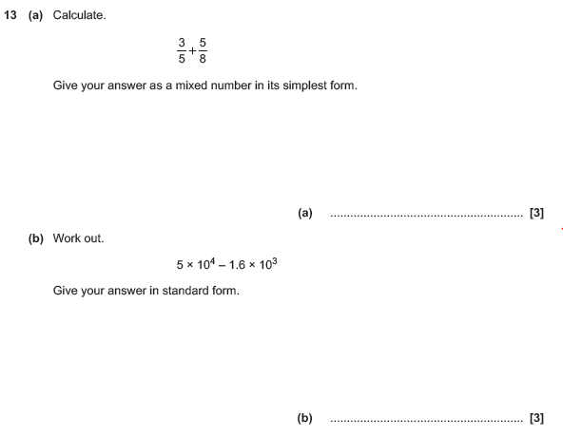

OCR Tuesday 12 June 2018– Morning (Calculator) Foundation Tier
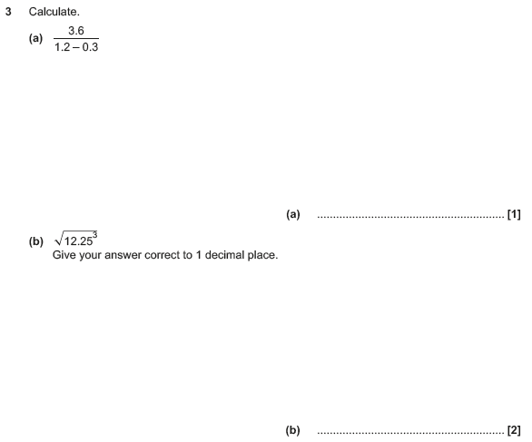

OCR Tuesday 12 June 2018– Morning (Calculator) Foundation Tier
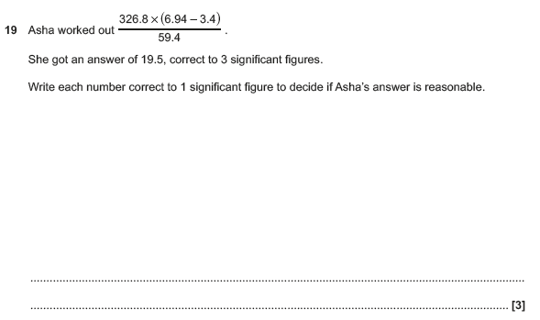

OCR Wednesday 8 November 2017– Morning (Calculator) Foundation Tier
- 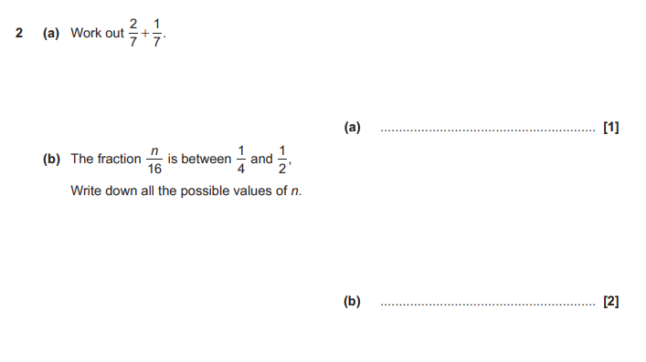
OCR Thursday 8 June 2017 – Morning (Non - Calculator) Foundation Tier

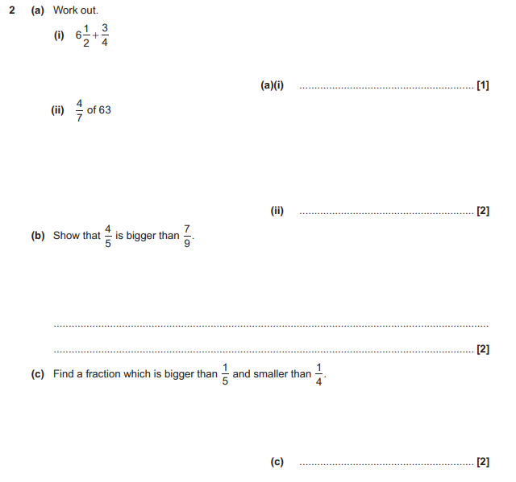

OCR Thursday 8 June 2017 – Morning (Non - Calculator) Foundation Tier

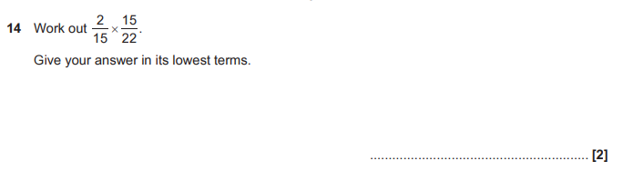
AQA Wednesday 8 November 2017 – Morning (Calculator) Foundation Tier

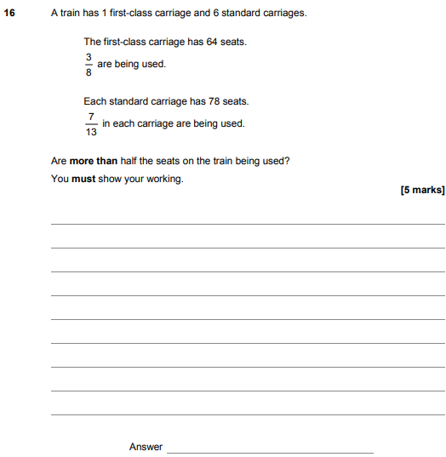
AQA Sample Paper 1– Morning (Non-Calculator) Foundation Tier

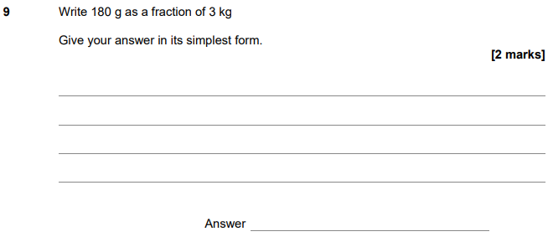

AQA Sample Paper 2– Morning (Calculator) Foundation Tier

